Simon Little releases second album The Knowledge of Things To Come

Having been experimenting with live-looping technology for the past few years and following the success of his debut solo album Mandala in 2010, bassist Simon Little has now released his second album The Knowledge of Things To Come.
Best known for his work with The Divine Comedy, Clare Teal and Duke Special, Simon has appeared on numerous recordings. This is the second release under his own name.
The entire album was recorded using solely his Warwick Thumb Bass VI, the Looperlative LP1 and a Pod X3 Pro. Each track is a live improvisation using live looping technology. He explains:

I’m still obsessed with making music using the bass as a lead instrument.
Live looping has opened up so many doors creatively and I feel like I’m just scratching the surface of what is possible with the LP1.
With this album I wanted to remove the music even further from the sound of the solo bass. The addition of the Pod X3 has helped me create an array of sounds giving the effect of several instruments playing together as a band rather than me alone.

The Knowledge of Things To Come is available now as a digital download at Simon’s website http://music.simonlittlebass.com and via most major music download providers.

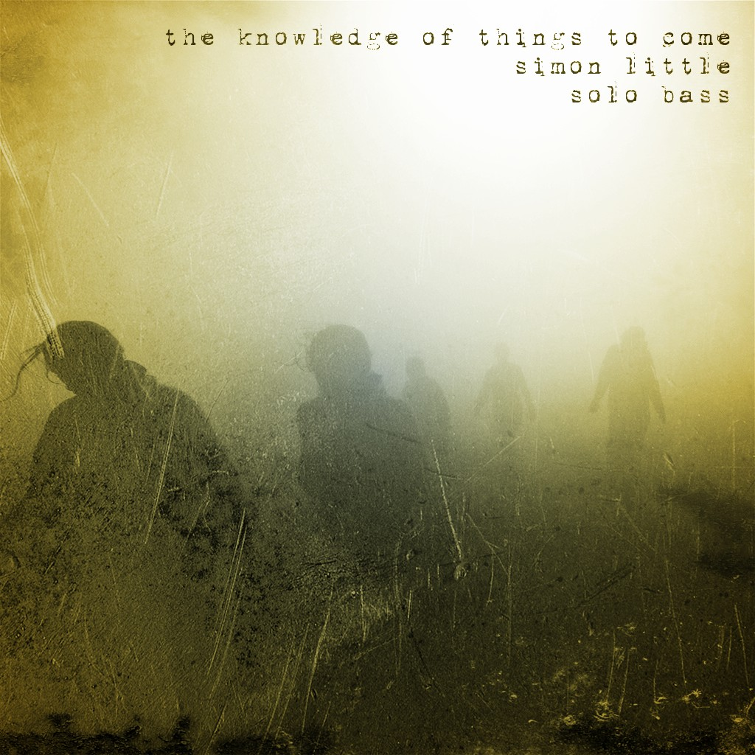

Simon is now continuing writing and recording for his next project Little Alex, a duo with drummer Steve Alexander. Their debut album is expected later this year.

